PRESS RELEASE Vienna, AT, January 22, 2024

**Austria is preparing for the Deposit Return System, Sensoneo will implement the software solution.**

Vienna – Austria will soon introduce the Deposit Return System (DRS) for single-use beverage containers, starting on January 1, 2025. The central body of Austrian DRS, [EWP Recycling Pfand Österreich gGmbH](https://www.recycling-pfand.at/), has chosen [Sensoneo](https://sensoneo.com/) in the public tender to deploy the IT solution, which will serve as the central infrastructure for the entire DRS system.

Currently, only 70% of single-use beverage packaging is being collected in Austria for recycling purposes. The main goal of the country is to reach 80% of collecting rates shortly after deployment of the DRS in 2025, and 90% rates in 2027. From 1 January 2025, all PET bottles, and metal cans with a quantity of 0.1 to 3 liters will be collected in the DRS scheme subjected to a deposit of 25 cents. These products will be identified by the deposit logo and can be returned to all sales outlets at which they are sold.

The Austrian DRS will be powered by a software solution from [Sensoneo](https://sensoneo.com/deposit-refund-system/). **This end-to-end and ready-to-integrate software for DRS** gathers data from all sources and **enables seamless integration between all stakeholders within the process chain.** SW is built on cloud-based infrastructure and **is agnostic with any return vending machine.** Austria is already the sixth country that has chosen the software solution from Sensoneo. The company won all the last 6 public tenders for DRS in Europe, among them the world's largest centralized DRS in Romania, further the DRS systems in [Slovakia](https://sensoneo.com/reference/deposit-return-system-in-slovakia/), [Malta](https://sensoneo.com/malta-deposit-return-scheme/), Ireland, and Hungary. The IT system for Slovak DRS was implemented in only 10 months, currently reaching 93% in recycling rates.

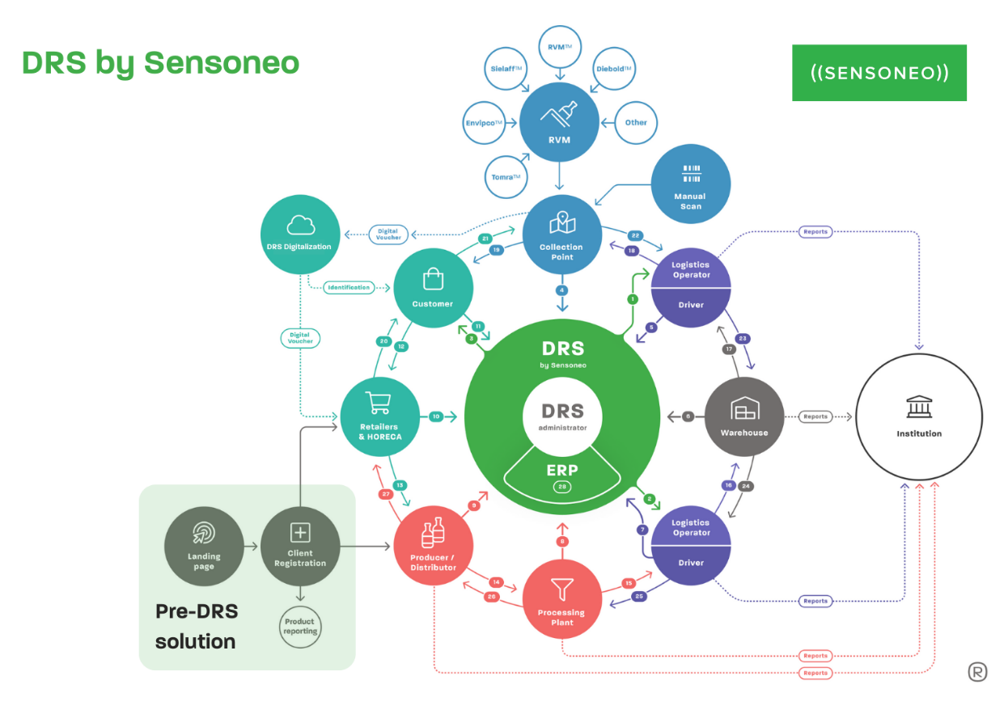

Figure : Full DRS Lifecycle, intellectual property of Sensoneo

-End-

**About Sensoneo:**

Sensoneo is a global technology company providing innovative solutions for waste management. Through the integration of cutting-edge technology, including robust software and a data-driven approach, Sensoneo enables cities, businesses, and countries to enhance their sustainability performance, optimize waste collection processes, and lower their environmental footprint.

As the sole company worldwide, Sensoneo successfully implemented software for Deposit Return Schemes (DRS) in more than five countries achieving a recycling performance exceeding 90%. Additionally, Sensoneo has designed tools to automate waste collection in factories, enabling its customers to improve waste diversion rate and circularity of the location. As a result, customers can achieve a real-time overview and 97% accuracy in actual waste production.

Sensoneo's smart waste management solutions have garnered attention from countries, cities, and businesses worldwide, with installations in over 85 countries across five continents. The deployment of smart sensors by Sensoneo is poised to contribute to the largest smart waste installation worldwide, encompassing an impressive 11,100 sensors in Madrid. Notably, Sensoneo holds the distinction of being the pioneering company to implement a narrowband IoT solution in the United States.

Find out more: https://sensoneo.com/

**For media inquiries, please contact:**

Martina Susova

PR & Communications Manager

martina.susova@sensoneo.com