PRESS RELEASE Cluj, RO, November 28, 2023

Romania is launching the Deposit Return System, using Sensoneo’s IT solution.
Cluj – Romania launches the world’s largest centralized Deposit Return System with almost 80.000 collection points. Romania is thus on the path to joining other 13 EU countries that have launched deposit return schemes (DRS) with the aim of increasing collection and recycling rates of single-use beverage containers.
The Romanian DRS system uses a software solution from Sensoneo, a technology company based in Slovakia. The software works as a backbone of the entire system as it integrates all stakeholders and gathers data from all sources within the process chain. The Deposit Return Schemes increase the purity of material collected, leading to materials’ circularity and reduction of CO2 emissions. The Romanian scheme will cover plastic, glass, and metal beverage containers ranging from 0.1 to 3 Liters. The deposit per bottle will be 0,5 Romanian lei (approximately 0,1 €).
All legal entities that produce, import, or sell beverages in single-use containers are obliged to participate in the scheme. The official launch of the Deposit Return System is due on 30 November 2023. The Deposit Return System in Romania aims to achieve global prominence as the most comprehensive integrated system, distinguished by its remarkable complexity. The establishment of the DRS system faced complex challenges in multiple aspects, encompassing equipment setup, software integration, and the identification and securing of appropriate locations for regional centers.
The system operator is RetuRO, a consortium uniquely consisting of a combination of private entities (associations of beverage producers and retailers) with minor public participation (through the Romanian Ministry of Environment, Waters and Forests). RetuRO will manage around seven billion beverage containers annually with Romania struggling in Europe when it comes to the rate of recycling. As Cristian Mihai, IT Director of RetuRO, explained: “Despite many challenges, we managed to implement a very complex system in an unbelievably short time. We are talking about an extremely complex, modular system, which will have to not only support the information received from almost 80,000 economic operators but also correlate identification, stock, return, collection, invoicing, and reporting data for almost 7 billion packages. The novelty and the revolutionary nature of this system make it equally exciting and provocative.”

The role of Sensoneo in Romanian DRS
Sensoneo designed a unique and ready-to-integrate IT system for DRS that can be adapted to any specific needs of different countries and is agnostic with any return vending machine. In the preliminary phase, Sensoneo provided a market-mapping tool that enabled the most efficient DRS implementation including digital data collection and analysis from all entities, registration of entities and their beverages into the system, and automated digital contracting.
Sensoneo’s full DRS system includes modules for every activity involved in the preparation, operation, and reporting. The main modules of the system are represented by the web portal for producers and retailers, the packaging register, the collection points register, the ERP (enterprise resource planning) system, the reporting system, the document management system, interfaces with other systems (RVM, counting and sorting centers), and mobile applications. All these modules are hosted on Microsoft Azure Cloud infrastructure which provides unlimited performance scaling opportunities and a high level of security protection. The modules reflect specific requirements and needs and completely fulfill each stakeholder's obligations. Martin Basila, CEO and Co-Founder of Sensoneo: “We are very proud to take an important part in building the world’s largest integrated Deposit Return System. We are thrilled to contribute to this groundbreaking initiative with our cutting-edge software tailored to customer’s unique demands. Sensoneo is committed to providing innovative solutions that align seamlessly with the intricate requirements of this monumental project, and we look forward to playing a pivotal role in the success of the Romanian Deposit Return System."
Sensoneo draws on its extensive experience with Deposit Return Schemes and is currently the only DRS integrator that operates in five European countries. In addition to Romania, Sensoneo's DRS IT solution serves as the central infrastructure for the entire DRS system in Slovakia, Malta, Ireland, and Hungary. Sensoneo implemented the Slovak DRS System in only 10 months, currently reaching 93% in recycling rates. According to Peter Knaz, the Head of Sensoneo’s DRS and Take-Back division: “We are happy another European country is on the path to implementing Deposit Return Scheme. I believe it is the right step for Romania to increase the recollection of clean material streams and decrease waste pollution. Our DRS IT solution is a perfect fit for large-scale deployment as it provides one stop shop platform for all stakeholders of the DRS system with a high level of waste management automation and financial streams.”
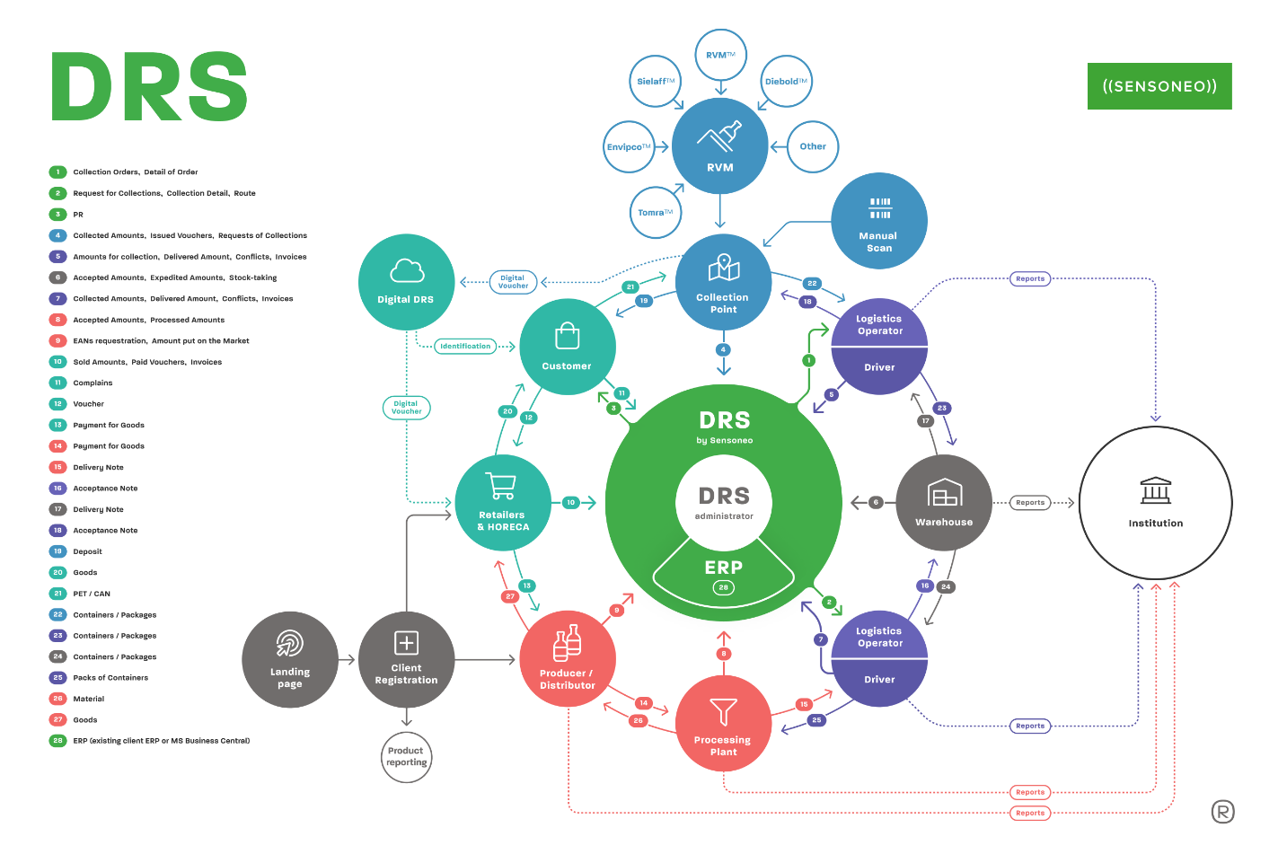
Figure 1: Full DRS Lifecycle, intellectual property of Sensoneo
-End-
About Sensoneo:
Sensoneo is a global provider of innovative waste management solutions. By leveraging cutting-edge technology, including robust software and a data-driven approach, Sensoneo helps cities, businesses, and countries optimize waste collection processes, improve sustainability performance, and create more efficient and cleaner public spaces. With a comprehensive suite of software and hardware solutions, Sensoneo is at the forefront of revolutionizing waste management.
As a result, customers can achieve a 30-63% reduction in waste collection routes and 97% accuracy in actual waste production. Sensoneo's smart waste management solution has garnered attention from cities and businesses worldwide, with installations in over 85 countries across five continents.
Sensoneo holds the distinction of being the pioneering company to deploy a narrowband IoT solution in the United States. Smart sensors by Sensoneo are poised to contribute to the largest smart waste installation in Europe, comprising an impressive 11,100 sensors in Madrid. Additionally, Sensoneo stands as the sole company worldwide to successfully implement deposit return scheme (DRS) systems in more than five countries.

About RetuRO
RetuRO Return Guarantee System S.A. ( www.returosgr.ro ) is a company operating on a not-for-profit basis – which means that any profit made by the company from the collection of beverage containers will be reinvested, exclusively, in the development of DRS. The company was created by a consortium of three private shareholders: the Brewers of Romania Association for the Environment (30%), the Association of Soft Drinks Producers for Sustainability (30%) and the Association of Retailers for the Environment (20%) and a public shareholder, the Romanian state, through the central environmental authority, the Ministry of Environment, Waters and Forests (20%).
RetuRO, the DRS administrator, operates with exclusively private financing and has the role of ensuring transparency on the quantities of beverage containers placed on the market and returned by consumers, contributing to the sustainable development of Romania, through responsible management of containers waste, in order to achieve the recycling targets imposed on Romania by the European Union.

For media inquiries, please contact:
Martina Susova
PR & Communications Manager
martina.susova@sensoneo.com

